(Functional) Architecture Review Board
Design Proposal Template 2024 – v2.0

Additional Assignment Instructions
The following are instructions specific to the Impact architecture assignment. The rest of the document is the standard ARB. These specific instructions do not replace the ARB ones, just give some emphasis:
- Make sure to include diagrams for the following: Store App diagram, component diagram, flow diagram. Consider what resolution these last two should be at, and the possibility to have more than one to cover high level overview as well as more detailed. The component and flow diagrams can be combined if you feel it serves the clarity of your presentation. You may, of course, include additional diagrams as you see fit.
- Leverage / reuse SN components and products as much as possible and call out when and how you do this.
- You may use any existing SN technology. You may include external technologies as relevant, as long as the solution is SN based.

Instructions
- This document is intended to help you share and present your design in Platform ARB, Functional ARB or both.
- Consult criteria for both Platform ARB (Appendix A) and Functional ARB criteria (Appendix B). If you meet any of the criteria, then prepare & schedule reviews for one or both ARBs. See also KB links.
- Not all sections are required – it is perfectly fine to skip sections that are not relevant to your design proposal. Each Section has content guidance/recommendations
(click [¶] button to hide/see detailed instructions).
- The sections are there to help you cover all important points, please use them as a checklist.
- Key Links
  - (Platform) ARB process: KB0542151
  - FARB & CMDB process: KB0549389

Document Information
Name | Name | Business Unit / Team
Feature Name
Author(s) / Submitter(s)
Primary Champion
Secondary Champion
[FARB] virtual-Team Members (when applicable)
EPIC link
Release (Target or True-up)
Proposed Merge Date

  - Table of Contents
1 Executive Summary 2
2 Design/Architecture Detailed Proposal 3
2.1 Feature & Functional Design 3
2.2 Technical Design 3
A. (Platform) ARB Entry Criteria 5
B. FARB Entry Criteria 6

Executive Summary
<This is a summary of your design proposal and should be as compact as possible and ideally not exceed one page. Provide all the needed high-level details such that the reader all the information needed to know what you are proposing, why, when, etc. (This text will not print. You can hide by clicking [¶] button or simply delete the text)>

Why are we presenting at the (Functional) Architecture Review Board?
<Please go through Appendix A & B and indicate which entry criteria apply to your feature. Highlight any possible concerns for the (F)ARB team. Ex. Risks of the feature, performance / scalability / security concerns, dependencies on other teams or libraries.>

What are we doing?
<Provide an overview of the feature / service and what is being done.>

Why are we doing it?
<Provide a reason for why this is needed and what it does better or different than what exists. Describe the business problem and/or technical problem that needs to be addressed. >

How are we doing it?
<Provide a summary of how the design will be deployed and where. Ex. GTM will be enabled on the existing production F5s in IAD and LHR.>

When are we doing it?
<Provide a timeline for development, testing, and merge. Mention if this feature spans family releases.>

Design/Architecture Detailed Proposal

Product/Capability/Feature Overview,
<Requirements and Use-Cases: describe from customer/user/persona point of view. List Epics and Stories if available. Description should include Purpose and/or desired customer & user outcomes.>
<Workflow and (sub-)processes: which top-level workflow and/or sub-processes does the product/feature provide or is part of. Include process flow diagram (chevron and/or sequence diagram>

Product /Feature Interoperability & Better-Together
<Describe Product, Platform and/or 3rd party Service alignment, interoperability, and reuse considerations with other products (family and/or store releases).
Identify Products and Teams that have similar and/or overlapping capabilities. And which teams (including Application and Platform Engr.) did you consult, interact and/or align with?>

UI/UX Summary Overview
<Overview of UI/UX pages, typically reflecting the top-level process and workflows. If you are considering custom components, you would add those to the proposal.>

Feature & Functional Design
<Address each of the bullet item topics in the next sub-sections and add as needed>
<Where applicable describe the alternatives and design choices, the pros and cons, and what decision was taken. List key assumptions that were made. List limitations of the solution, if known, and any technical debt.>

Feature/function decomposition
- Summary description of the new, incremental and/or changed features, functions and capabilities.
- Provide overview of how functionality is broken down across modules and/or sub-systems (self-provided or provided by other product teams, platform team and/or 3rd party integrations)

Plug-in structure & modularity
- List and describe any added or modified components, including Tables, Data formats, Properties, Scheduled Jobs, scripts, rules, UI/UX, roles, etc. Provide 1-2 line description.
- Plug-in design: modularity as well as dependencies on key other functional plugins, shared services and/or Apps + overview of application scope(s).
- Better-Together and Re-Use.
- License and entitlement considerations, including Roles and Personas.

Data Model details
- Provide high level ERD diagram (Lucid preferred), ideally mapped to plug-in hierarchy + table extension model (in general try to avoid class hierarchy from ERD diagrams).
- ERD and Class Diagrams should include new/modified tables, table hierarchy, references, and relations between tables. Include a short description of each new table.
- Table and field names in the diagram should be accurate. Labels are optional but preferred (required for class extension model). Table color coding guidelines: white for existing tables/fields, green for new/additional, yellow for changes.
- Per each new table:
  - Which class it extends?
  - Did you investigate other similar classes in the model and decided not to re-use them? If so, please explain the considerations.
  - What are the identification rules: dependent/independent, attributes
  - Why did you decide to extend and not use the base class?
  - Did you investigate other possible new use cases where this table might be used?
- New/modified field description is required in case the field name is not self-explanatory.
- Per each new field in exiting table, or a field in a new table
  - Provide type, length (if relevant), name, label, hint, choice list if relevant.
  - Are there new indexes?
  - Is there a reason why the new fields should not go to the parent class?
  - Did you verify there are no fields with similar name or meaning in the base classes?
- Overview of persona and role specific ACLs, preferably by table if there are variances.
- List any sys_metadata tables.

Figure 1. Example ERD diagram.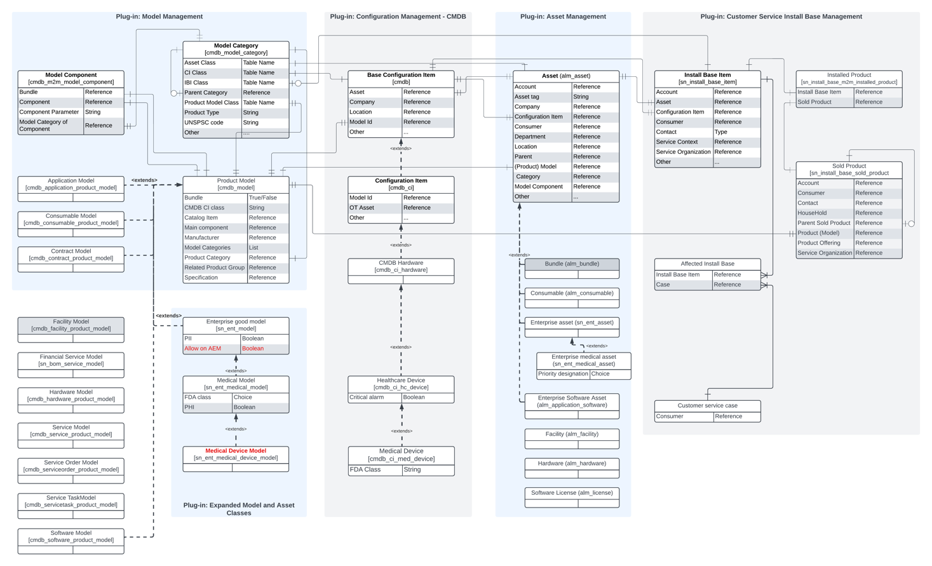

Integrations
- List new and changed integrations, with summary of existing integrations (internal and external).
- Show and describe dataflows and add dataflow diagrams where applicable.

Impactful Changes
- Does this proposal represent an “Impactful Change” per KB0546588? If so, please note what teams are affected and how they are affected. You should also engage in the impactful change process.

Technical Design
<Address each of the bullet item topics in the next sub-sections and add as needed>

Scaling
- List the key data, processing, integration scale considerations for this proposal.
- Provide the projections for the top 5-10 customers by size for the specific feature or capability.

Performance and Testing
- Performance considerations: Scale (data, process flows, interactions, users, etc.), throughput (time unit), retention.
Provide customer and/or use-case specific scale & scope estimates and assumptions.
- What are the main testing strategies for this feature.
- Performance test design.
- What are the highlights [Added features, functional testing, debugging steps].
- Specify testing strategy for data model.

Upgrade path
- Upgrade path for existing customers.
- Migration considerations.
- Fix scripts needed?
- Schema changes?
- Upgrade time impact. Identify major customers and their expected & tested upgrade times.
- Skipped script include/business rules likely?

Security and Information/Data governance
- Which sensitive data to protect
- Domain separation
- Scoped administration/RCA
- Unauthenticated user access
- Outgoing/incoming authentication

Risks and dependencies
- List risks or dependencies regarding implementing this feature or regarding NOT implementing it.
- List risk remediation/mitigation options and considerations.

Other
- List any other relevant technical design considerations.

- (Platform) ARB Entry Criteria

Entry Criteria | Applicable? | Considerations
Functionality / Performance Impact
- Requires material new java code | Y/N | - Consider filing for patent.
- Stores/retrieves > 10,000 rows in a large instance | Y/N | - Ensure that proper indexes are created.  - Create and Present a Data Model Diagram.
- Adds a new 3rd party project dependency (jar file added to POM) | Y/N
Infrastructure / Performance Impact
- Requires a modification to technology or traffic flows for the SNC application or creates a new data exchange with a shared service | Y/N | - Create and Present a Data Flow Diagram Below.
- Involves modifying the network design or topology standards (including a new central instance or shared service) | Y/N | - Create and Present a Data Flow Diagram Below.
- If it requires any new (or adds significant load to any existing) Service, Solution or Hardware standard | Y/N | - Document load expectations against available capacity.  - Document mitigations for slow or unavailable services.
Security / Privacy / Compliance Impact
- Adds/modifies interfaces or APIs to existing services/solutions (including adding/changing scope-accessible APIs, publicly accessible global Script Includes, web services, or External REST APIs) | Y/N | - Use authentication and Authorization (ACL)  - Sanitize user inputs against injection  - Escape user provided data against XSS when transmitting it to the browser  - Limit the size of payload and enable rate limits.  - Test performance when adding complex ACL or other type of complex security control in the interfaces or APIs
- Requires new or updated 3rd party software (open source and/or commercial licenses) or 3rd party API | Y/N | - Submit OSS 3rd party tickets on BT1 for new / updated packages 2 months before final merge.  - Submit Commercial 3rd party integration tickets on BT1 4 months before final merge.  - Do not use 3rd party software with known CVE  - Vendor Risk Assessment required for the 3rd party web services or REST APIs
- Changes the scope of privacy or security standards (e.g. encryption mechanism, data visibility, domain separation) | Y/N | - Changing existing ACLs, encryption, or any other security features for PII, encryption keys, credentials or any other sensitive records  - External users having access to the instance as internal users  - Any change in the security standards such as encryption or hashing (3DES, AES 128, AES 256, SHA-1, SHA-2, or ECC)
- Requires any changes or access handlers' addition to a platform feature or plugin | Y/N | - Making any change in the platform/plugin access handlers such as .canAccess() or .hasRightsTo() can significantly impact the overall security of the instance.
- Adds a new table with the public role | Y/N | - Any self-registered user can access any table with the public role without additional ACL.
Schema Impact
- Re-parenting any table | Y/N | - Analyze size of table being re-parented. A read-audit is likely required to determine.  - Use the reparenting tool.  - Consider impact to upgrade time.
- Adds a new child of sys_metadata or changes the update_synch setting of a new/existing table | Y/N | - Analyze size of table being re-parented. A read-audit is likely required to determine.  - See the Metadata Development Guide  - Recommend completing the Metadata Checklist  - Best Practices: 1) no unique indexes, 2) no references to non-metadata tables, 3) small tables, 4) support domain separation, 5) support string translations
- Creating a new virtual table | Y/N | - Document why table must be virtual, how data will be inserted and row size estimates.  - Consider use of pure virtual VTable instead of AVirtualTable
- Any dynamic table or metadata creation | Y/N | - Ensure the use case requires this functionality.  - Document any impact on licensing and usage analytics.
Upgrade Impact
- Creating a store app that forces customer instances to install your app during a family upgrade (mode=core) or forces all new/zbooted customer instances to install your app (mode=boot) | Y/N | - Consider impact to plugins (plugins cannot depend on your app)  - Consider future releases, not just scope for current release.  - Document the app schema and any script includes that other teams may use in a fix script.
- Has a risk to impact upgrade times (e.g. alters/schema changes not covered above, fix jobs, large data sets, etc) including a fix script that runs more than 1 minute. | Y/N | - Consider optimizing the fix script or selecting customers to upgrade schema prior to version upgrade.

- FARB Entry Criteria

Entry Criteria | Applicable
Application and Functional Criteria
- New product, Store app or product creation, including Better-Together use-cases | Y/N
- Enhancements to or partitioning of existing functionality | Y/N
- Adding a new framework/feature/component that can be used by other product BUs | Y/N
- Any data model change deemed impactful by BU data model champions (e.g. update and/or migration time > 4hrs) | Y/N
- Any CSDM related product, data or service model changes, additions or deviations | Y/N
- Creating new extension tables for Task, User, Company, Product Model. Asset. CI, Event or other platform and foundational entities | Y/N
- Any existing table growing to be a large table (>2 million records) | Y/N
- Following a design pattern that is different from the one other BUs followed | Y/N
Data Foundations ? CMDB and Data Model Criteria
- CMDB table additions, changes, extension (specifically for cmdb_ci, Configuration Item). Any changes to alm_asset, product model | Y/N
- References to cmdb_ci, incl. CMDB adjacent tables. | Y/N
- Tables that the IRE has OOB identification rules for (cmdb_ci or other tables). | Y/N
- Integrations or interactions with CMDB tables, incl.: cmdb_software_instance, cmdb_sam_sw_install, sn_vul_vulnerable_item, sys_object_source, cmdb_rel_ci, svc_rel_assoc, svc_ci_assoc. | Y/N
- Additions, changes, extensions, integrations for CSDM at product level, functional level and/or data model level

